Software System Design Documentation

Program name: Software Engineering
Module Name: Advanced Programming
Year/Semester: 2024-25 / Semester 2
Student number: HE27721
Module Tutor/s: Kishore Pashindla, Faisal Maramazi, Neelum Raffique

Date of submission:11/22/2025
Word count excluding references and TOC: 1850
Table of Contents
Introduction 2
Software Development Life Cycle 2
Requirement analysis 3
Candidate classes 4
Functional requirements 4
Non-functional requirements 5
System Design 5
Class Diagram 5
Global class 9
Sequence Diagram 10
Entity-Relationship Diagram 11
Use case Diagram 11
Design pattern 12
Development Plan 13
Testing 13
Conclusion 15
References 15

Introduction
This document presents a proposed design for a Ticket Booking System, created using the SDLC (Software Development life cycle) model Agile.
The purpose of the system is for people to be able to browse their chosen events, and purchase tickets using their preferred devices to avoid queues, delays and human errors in booking, while organizers and administrators manage events and oversee the activity.
This document consists of a brief about SDLC model, a requirement analysis, UML design diagrams, a development plan, testing strategy and a conclusion.

Software Development Life Cycle
“Software Development Life Cycle is a phenomenon of designing, developing and testing high-quality software.” (Shaikh, 2021)
Using a structured framework that guides these stages, called a software development model, the developers can follow a clear process and make sure that the software meets the requirements and purpose.
“Software Development Life Cycle models form the backbone of software engineering practices, guiding the systematic and structured approach to creating high-quality software products.” (Pargaonkar, 2023)
Agile is an SDLC model used for small projects, that offers flexibility, is better for small, capable teams, involves continuous feedback and it’s easy to implement changes throughout the process. It captures all the needs for this project.
While Waterfall is easy to follow through, since it involves completing a stage and moving on to the next, because of the repeated updates needed for this project, it was avoided.

Requirement analysis
“Requirements are established by the client, with help from the software engineer, whereas the technical decisions are often made by the software engineer without much client input.” (Tsui, 2023)
Before creating a program, it is important to know what the program is supposed to be doing, what it is required to do. For that, a requirement analysis is needed.
By talking with the stakeholders, learning about their expectations and needs, a picture is painted of what the output of the system should look like.
The UML class diagram on which the project is built is provided and explained later in the Class diagram section: 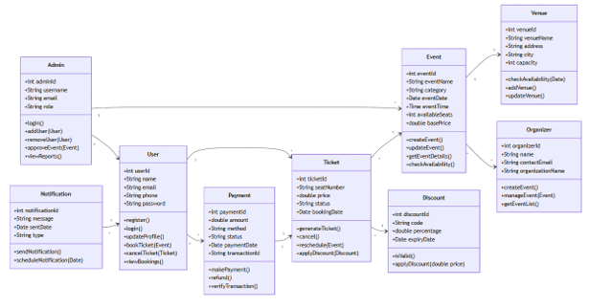

Candidate classes
Candidate classes involve a list of objects used to plan and show the main participants in developing a system.
Based on the UML diagram provided, the candidate classes in this system are: Admin, User, Notification, Payment, Ticket, Discount, Event, Venue, and Organizer.
They will be used as building blocks moving forward.

Functional requirements
“Functional requirements (FRs) describe the services the system should provide and how the system will react to its inputs.” (Laplante, 2022)
Functional requirements involve what the system should be doing. In this case, the system should:
- Allow clients to register and log in
- Allow clients to view events and book tickets
- Allow clients to make payments, apply discounts and receive notifications
- Allow clients to cancel/reschedule tickets
- Allow organizers to assign venues to events, create, manage and update event details
- Allow administrators to handle refunds, view sales and booking reports, approve events and manage users
- Allow real-time seat availability and process secure payments
- Must connect each event to a venue, and allow updates

Non-functional requirements
Non-functional requirements show how the system should work and the standards it should meet. In this system those are:
- Always being available for users to access and purchase tickets at any time
- The interface should be user-friendly and intuitive
- The system should be fast, and load details within a few seconds
- The system should be secure regarding user data and payments
- The system should be able to handle multiple access at the same time

System Design
“UML diagrams are formal representations of various software components and their stockholders; therefore, they play an important role in creating a software.” (Rosca, 2021)
With the use of diagrams, a bridge between stakeholders and the developer team is created to make sure everyone understands the program, what it does, how it does it, and the result.

Class Diagram
“Among the distinct types of UML diagrams, class diagrams stand out as a fundamental tool for representing the structure and behaviour of a software application.” (Apostol, 2024)
A class diagram helps by highlighting the important parts of the program. Classes are shown as tables, attributes describe the object and show what information they store, methods are the actions the object does.
Based on the UML class diagram provided:
Class | Attributes | Methods
Admin | Int adminID  String username  String email  String role | Login()  addUser(User)  removeUser(User)  approveEvent(Event)  viewReports
Notification | Int notificationId  String message  Date sentDate  String type | sendNotification()  scheduleNotification(Date)
User | Int UserId  String name  String email  String phone  String password | Register()  Login()  updateProfile()  bookTicket(Event)  cancelTicket(Ticket)  viewBookings()
Payment | Int paymentId  Double amount  String method  String status  Date paymentDate  String transactionId | makePayment()  refund()  verifyTransaction()
Ticket | Int ticketId  String seatNumber  Double price  String status  Date bookingDate | generateTicket()  cancel()  reschedule(Event)  applyDiscount(Discount)
Discount | Int discountId  String code  Double percentage  Date expiryDate | isValid()  applyDiscount(double price)
Event | Int eventId  String eventName  String category  Date eventDate  Time eventTime  Int availableSeats  Double basePrice | createEvent()  updateEvent()  getEventDetails()  checkAvailability()
Venue | Int venueId  String venueName  String address  String city  Int capacity | checkAvailability(Date)  addVenue()  updateVenue()
Organizer | Int organizerId  String name  String contactEmail  String organizationName | createEvent()  manageEvent(Event)  getEventList()

The relationships between these classes are association relationships. A User can receive many Notifications, purchase many Tickets, make many Payments while Notification, Ticket, and Payment is linked to one User. Tickets can have multiple Discounts applied, each Discount may be applied to many Tickets and each Ticket is used for one Event. Many Events are organized by one Organizer, each Organizer can manage many Events. Each Event is at one Venue, a Venue can hold many Events. Admins handle many Events and many Users.
This is the new class diagram proposed: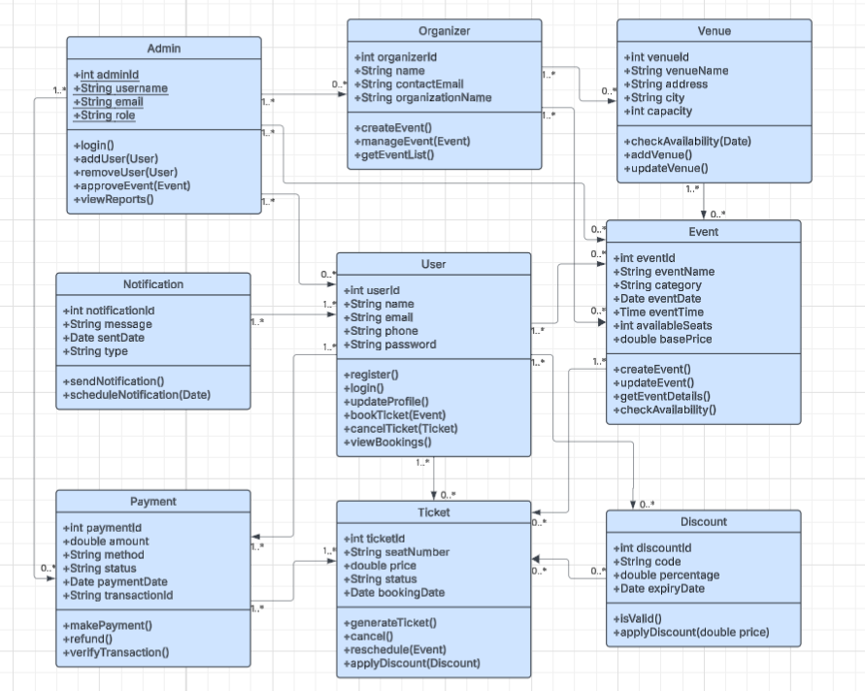
This is a table of relationships in the new diagram:
Class | Relationship
Admin | All Organizers, Payments, Events, and Users are handled by Admin
Notification | One or many Notifications are received by Users
Payment | A User can have 1 or many Payment methods
Ticket | One or many Tickets are purchased using Payment
User | A User can have 0 or many Tickets  0 or many Discounts are applied by Users
Organizer | An Organiser has 0 or many Events to manage  Organizers manage Venues
Venue | A Venue can have 0 or many Events
Event | An Event can have 0 or many Tickets  All Events can be browsed by Users
Discount | 0 or 1 Discount can be applied to 0 or 1 Ticket

Global class
A global class is used for storing shared methods and variables that are needed in more than one classes in the system.
It is used to avoid repeating code in every class. Everything common is placed in one main class so all others can access it.
For this ticket booking system, this global class may include formatting dates, system activity, create IDs, validate emails or payment methods.

Sequence Diagram
“Sequence diagrams are a representation of scenarios or use cases, something that traces back decades. The key design elements are the software object.” (Buede, 2024)
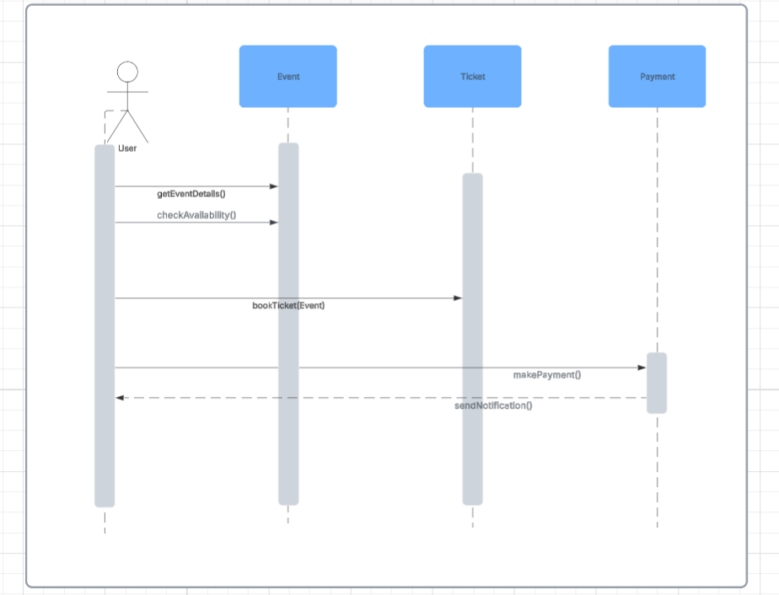
This sequence diagram shows what happens when a User wants to book a Ticket to an Event.

Entity-Relationship Diagram
This is the Entity-Relationship diagram for this system that shows the relationships between classes: 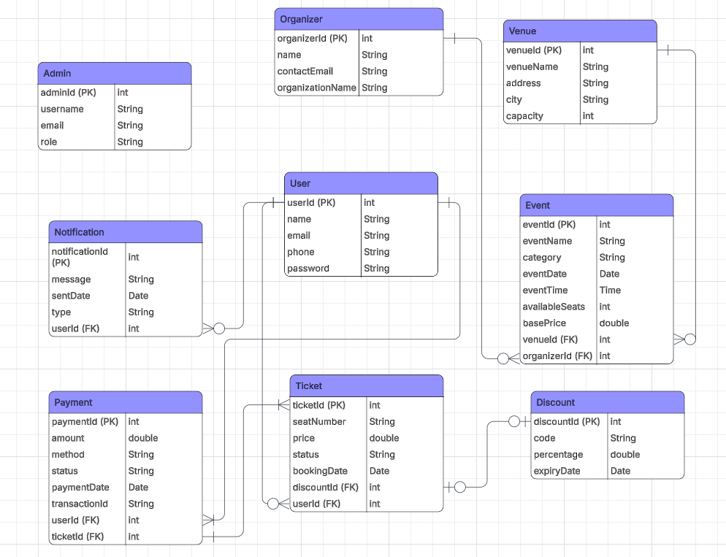

Use case Diagram
“The use case diagram describes the functional requirements of the software.” (Fauzan, 2021)
A use case diagram is needed to explain to stakeholders the “story” of the system: who are the users and how they use the system.
This is shown by using “actors” - represented by stick figures, and an ellipse to show actions. It’s simple, straightforward and easy to understand for people who are not familiar with technical vocabulary.
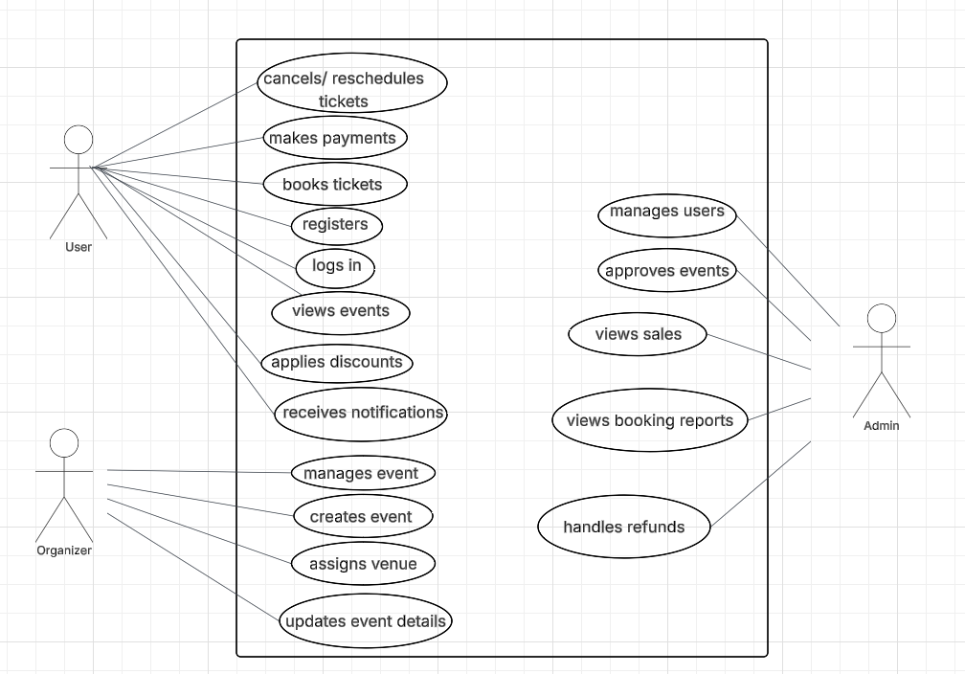

Design pattern
A pattern describes a problem and its solution, so that solution can be used in different settings. A design pattern can be explained be describing the patterns used.
To use patterns in the design, it is important to recognize if any design problem has an associated pattern that can be applied.
For this ticket booking system, the Iterator pattern was chosen. This pattern involves a standard way of accessing elements in a collection, that isn’t changed by the way the collection is implemented. Since this system is expected to display and loop through lists like events, tickets, payments, this pattern was chosen to make sure everything is accessible, reliable and easy to update to respect the stakeholders’ requirement of the system to be always functional regardless of future changes.

Development Plan
“Agile development calls for small, highly talented, highly responsive teams that construct software in small increments.” (Foster, 2021)
The Agile model was chosen for this project because of the small size of the development team, and the need for flexibility during design and implementation.
Lucidchart will be used as a graphical tool for creating and editing UML diagrams for its simplicity and accessibility.
The system will be created in Visual Studio using C# as the programming language, and MySQL will be used for database storage, as it is reliable and universally supported.
The testing tool will be NUnit, because of its testing framework is designed for C# apps and it allows automatic tests to be run.

Testing
“Testing monitors software quality and reduces risk by revealing faults at the development stage.” (Spillner, 2021)
After creating the program, to make sure it works properly, tests need to be conducted before presenting it to the stakeholders.
The system will go through 3 stages of testing: development testing - during developing, to discover bugs and defects; release testing – to check if the system meets the stakeholders’ requirements; and user testing – where users can test the system in their own environment.
Development testing has 3 stages: unit testing – the classes are tested; component testing – after the classes are integrated to create components, the tests focus on component interfaces that access the component functions; and system testing – after all components are integrated and the whole system is tested.
To make sure the requirements are met, a requirements-based testing will also be added to make sure the system does what it needs to do.
Scenario testing was added to cover all different types of situations that may appear and how the system responds to errors.
Because multiple users will be accessing the system, a performance testing is also needed to make sure the system can process the load.
User testing consists of 3 stages: alpha – a small group who works with the developers will test it; beta – for a larger group; and acceptance testing – to make sure if the system is ready.
Testing will happen after the development of the system. The schedule for the tests is the following:
Type of testing | Stages | Period
Development testing | Unit testing | Day 1
 | Component testing | Day 1
 | System testing | Day 1
Release testing |  | Day 2
Requirements-based testing |  | Day 2
Scenario testing |  | Day 3
Performance testing |  | Day 4
User testing | Alpha testing | Day 5
 | Beta testing | Day 6
 | Acceptance testing | Day 7

Conclusion
In this document, a simple Ticket Booking System proposal was presented using the SDLC approach. The requirements were identified, the UML diagrams were updated and a development and testing plan was created. Together, these elements will serve as a base for creating a program that meets the stakeholders’ needs.

References
Apostol, D.-C. B. (2024). UML Diagrams in Teaching Software Engineering Classes. A Case Study In Computer Science Class. 2024 IEEE 22nd World Symposium on Applied Machine Intelligence and Informatics (SAMI) (p. 1). Stara Lesna: IEEE. doi:doi.org/10.1109/SAMI60510.2024.10432905
Buede, D. M. (2024). The Engineering Design of Systems. New Jersey: John Wiley & Sons.
Fauzan, R. S. (2021, December). A Different Approach on Automated Use Case Diagram Semantic Assessment. International Journal of Intelligent Engineering & Systems, 14(1), 496. doi:doi.org/10.22266/ijies2021.0228.46
Foster, E. B. (2021). Software Engineering- A Methodical Approach. New York: Auerbach Publications. doi:doi.org/10.1201/9780367746025
Laplante, P. A. (2022). Requirements Engineering for Software and Systems. New York: Auerbach Publications. doi:doi.org/10.1201/9781003129509
Pargaonkar, S. (2023, August). A Comprehensive Research Analysis of Software Development Life Cycle(SDLC) Agile & Waterfall Model Advantages, Disadvantages, and Application Suitability in Software Quality Engineering. International Journal of Scientific and Research Publications, 13(8), 121. doi:http://dx.doi.org/10.29322/IJSRP.13.08.2023.p14015
Rosca, D. D. (2021). A Systematic Comparison of Roundtrip Software Engineering Approaches applied to UML Class Diagram. CENTERIS- International Conference on Enterprise Information Systems. Lisbon: Science Direct.
Shaikh, M. K. (2021). Comparative Analysis of Trending Agile Model Tools for Software Development Life Cycle. Jeju, South Korea: KSII The 13th International Conference on Internet (ICONI).
Spillner, A. L. (2021). Software Testing Foundations. Paderborn: Publisher's Group UK.
Tsui, F. K. (2023). Essentials of Software Engineering. Burlington: Jones & Bartlett Learning.

